SQ Heat Treat Supplier Management Procedure

PURPOSE:
The purpose of the SQ Heat Treat Supplier Management Procedure is to provide the process to evaluate potential Heat Treat Suppliers and to define how Allison maintains the Approved Heat Treat Supplier List

SCOPE:
The SQ Heat Treat Supplier Management Procedure and Approved Heat Treat Supplier List apply to all SQEs and/or assignees.

DEFINITIONS:
SQ Supplier Quality
SQE Supplier Quality Engineer
ATI Allison Transmission Incorporated
OS Opportunity Scenario
Allison Supplier Management Portal Portal used to manage supplier quality related documentation.

REFERENCES:
AT-1927 Supplier Quality Manual
AT-1927-16 Process Control Plan Audit
AT-1927-30 Supplier Process Change Evaluation (SPCE)
AT-1927-87 Heat Treat Approval List (Supplier Copy)
AT-1927-88 TPS-301 Heat Treat Certification Form
AT-1927-89 TPS-254 Heat Treat Certification Form
AT-1927-90 TPS-300 Heat Treat Certification Form
AT-1927-91 TPS-269 Heat Treat Certification Form
AT-1927-92 TPS-247 Heat Treat Certification Form
AT-101528 Heat Treat Checklist
CQI-9 AIAG Special Process, Heat Treat System Assessment

TABLE OF CONTENTS:
Section A - Evaluation of Potential Heat Treat Suppliers and Approval Page 2
Section B - Allison Approved Heat Treat Supplier List Maintenance Page 3
Table A - Approved Heat Treat Supplier Cadence (Table) Page 4
Allison Heat Treat Certification Forms and Examples Pages 5-10

Section A – Evaluation of Potential Heat Treat Suppliers and Approval

Heat Treat Process (and supplier) approval at PPAP

During the time of PPAP of a new component that requires Heat Treat, it is the responsibility of the Tier I supplier to identify who will be processing the parts for Heat Treat, and who the source is (if external to their facility)
  - Tier I source processes parts per the applicable ATI technical specification (TPS) and required technical documentation for evaluation to Allison SQE and/or Allison Materials Engineering Lab

- Heat Treat Process change approval of a current production part.
  - Tier 1 supplier submits a request to ATI commodity manager for request of Heat Treat Supplier change via supplier process change evaluation form (SPCE)
  - The commodity manager assesses the SPCE and processes the documentation per the SPCE procedure.
  - The SPCE is screened, and reviewed internally at ATI by the Procurement Team, the applicable Product Line Team (PLT), and the Materials Engineering Lab
    - An approved SPCE would generate an associated OS and drives a PPAP requirement in the Allison Supplier Management Portal
    - A rejected SPCE would be sent back to the supplier, with comment/reasoning or further action required for the Heat Treat Supplier change to be accepted by Allison.
  - If the chosen supplier on the SPCE form is currently not on the Approved Allison Heat Treat Supplier List, then that supplier must go through the evaluation process.
    - The potential heat treat source, at a minimum, provides to Allison for evaluation:
      - The Allison Heat Treat self-assessment form
      - Their latest CQI-9 Heat Treat System Assessment
      - Any other pertinent information requested by Allison.

- Heat Treat Supplier Evaluation
  - Prior to approval and addition to the Allison Approved Heat Treat Supplier List, the potential heat treat source must complete an onsite evaluation.
  - During that evaluation, the Allison SQE completes the evaluation utilizing:
    - Allison Process Control Plan Audit (reference AT-1927-16)
    - Heat Treat Checklist A-101528
  - During the Heat Treat supplier audit, the supplier should provide supporting documentation which speaks to the strength of their Heat Treat process:
    - Heat Treat procedures
    - Heat Treat equipment and tooling calibration history
    - Part inspection plans
      - Inspection results
    - Process monitoring systems.
    - Temperature uniformity surveys
    - Internal systems audit process and prior data
    - Other associated process documentation
  - After the heat treat supplier audit is complete, the Allison SQE assesses the supplier’s ability to process Allison parts with regard to the applicable technical specifications.
    - If the supplier is approved, they will be added to the Approved Allison Heat Treat Supplier List
    - If the supplier is “conditionally approved” or “rejected”, the Allison SQE will document the reasoning for the status via an open issues list, and where applicable, work with the supplier to gain full approval status.
      - Depending on the reason for a “conditional approved” status, some suppliers may be added to the Approved Allison Supplier Heat Treat List.
      - Where applicable, the Allison SQE can utilize the Materials Engineering Lab for technical support in the development of a supplier.

Section B – Allison Approved Heat Treat Supplier List Maintenance

- Suppliers currently on the Allison Approved Heat Treat Supplier list will remain approved if they meet one or all of the following criteria:
  - Ship parts to Allison, or Allison Tier I sources, for approved TPS specification processing within the last 12-month window.
  - If heat treat supplier processes parts within 12 months and has no issues with new PPAPs or revisions
  - Pass Allison Materials Lab part sampling inspection with no major issues.
  - Pass audit process (Allison Process Control Plan Audit, CQI-9, or Allison Heat Treat Audit)
- A supplier that is currently on the approved list can have their status change to “conditionally approved” or “rejected’ based upon:
  - Failed heat treat audit.
  - Documented quality issues.
  - Failed part sampling by Allison Materials Lab
  - Not shipping Allison products for greater than 12 months
- A supplier that fails to maintain the necessary quality system and technical processing capability that results in them being moved to the status of rejected, must work with the Allison Procurement organization to develop a recovery plan.
  - Failure to do so could result in a complete exit from that supplier as a source for Heat Treat components.
- Allison designates two types of Heat Treat Suppliers:
  - Commercial Heat Treat Supplier – Supplier who processes commercial products to enhance the mechanical properties of materials for multiple customers.
  - Internal Heat Treat Supplier – Supplier that has capable heat treat technology and processing available and in use for them to enhance the mechanical properties of materials.
    - Internal Heat Treat Suppliers are not approved to process another Tier I sourced parts.
    - It is the responsibility of both Commercial and Internal Heat Treat Suppliers to monitor their outsourced processing including:
      - Incoming inspection of Heat Treat certificates with each batch of material
        - Allison requires that Heat Treat Suppliers provide the Heat Treat Certification Addendum in addition to the standard heat treat certificate.
          - The Heat Treat Addendum can be found on the Allison external website.
      - Periodic review of Heat Treat processing via documented auditing process
      - Where applicable, use of 3rd party company for analysis of chemistry and metallurgy
- Allison maintains Technical Specifications and Approved supplier lists on the external Allison website (reference Allisontransmission.com, Supplier Quality Forms (AT-1927-87), and Purchasing Related Forms (F11097)
  - Per CQI-9 (section 1.5), it is the responsibility of the supplier to maintain a procedure that ensures that all customer specifications are up to date.
  - Allison requires that Tier I sources maintain their own list of approved suppliers, their approval process, and how their supply list is maintained.
- The audit schedule for suppliers on the Approved Heat Treat Supplier List is based upon supplier performance, and necessity. Reference Table A for criteria for auditing.

TABLE A – Approved Heat Treat Supplier Audit Cadence

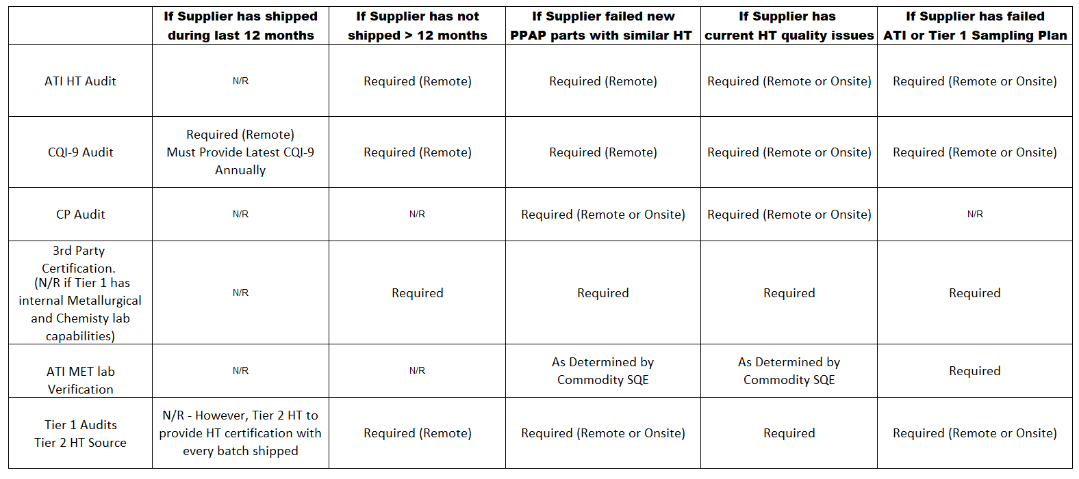

Section C – Heat Treat Certification Procedures and Completed Form Examples

1. Heat Treat Suppliers (Tier 2)

Allison heat treat suppliers are required to provide standard certifications with supplier’s letterhead and format and include all relevant data necessary to assure print and spec requirements.
- In order to assure heat treat supplier has provided all data necessary to comply to print and TPS spec, the heat treat supplier is required to fill out the ATI formatted heat treat certification forms identified as:
  - Heat Treat Certification - AT-1927-88 form which refers to TPS-301
  - Heat Treat Certification - AT-1927-89 form which refers to TPS-254
  - Heat Treat Certification - AT-1927-90 form which refers to TPS-300
  - Heat Treat Certification - AT-1927-91 form which refers to TPS-269
  - Heat Treat Certification - AT-1927-92 form which refers to TPS-247
- Please note:
  - The Heat Treater’s standard certification along with the ATI heat treat forms must be attached to every production batch and both certifications should be available electronically since the Tier 1 should be reviewing each certification prior to shipment.

2. Machiners (Tier 1)

- The ATI Tier 1 supplier should work with the heat treat supplier to assure that both the supplier heat treat certification and the ATI heat treat certification forms include all necessary data to comply to ATI specs.
- ATI Tier 1 machining suppliers are required to monitor and assure that the heat treat supplier is providing both a completed standard certification along with the specific ATI heat treat certification during every production batch, GP-11 and PPAP.

AT-1927-91 Heat Treat Supplier Management Procedure

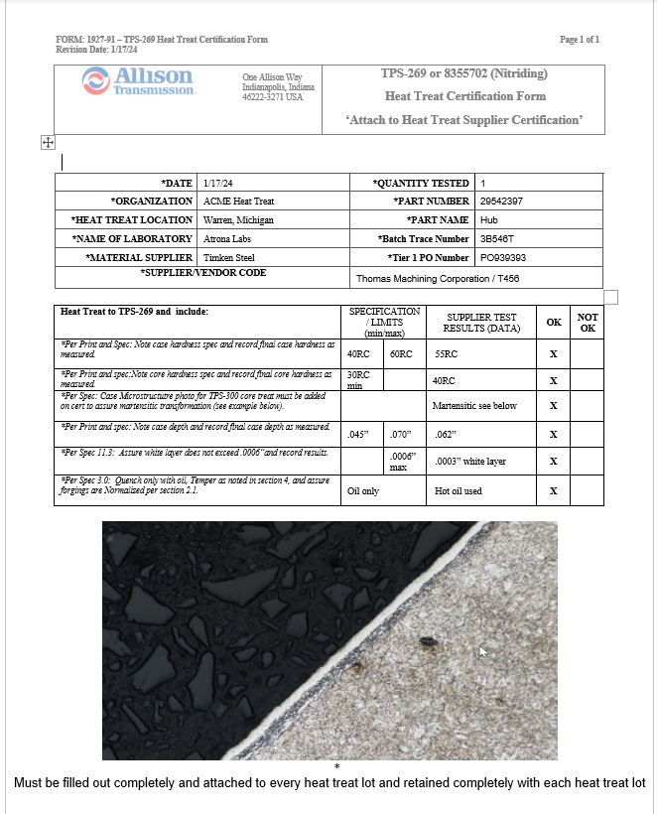
Verify quenching substance is oil, not soluble water, and ensure TPS-247 certification was added if parts are forgings.
Record white layer and ensure it does not exceed .0006”.
Note case depth on nitrided treated surfaces.
Show microstructure photo for the entire part per TPS-300. In order to show the white layer, case depth of TPS-269 and TPS-300 microstructure. The photo should be attached as shown directly from the mounted section sample. No dictation allowed.
Note core hardness print requirements that were achieved by core treating per TPS-300 process.
Note case hardness for the Nitride print requirements.
*Follow CQI-9 for frequency check requirements
Microstructure checks changed from “every batch” CQI-9 Revision 3 to
“Once per day per furnace” on CQI-9 Revision 4.

AT-1927-90 Heat Treat Supplier Management Procedure

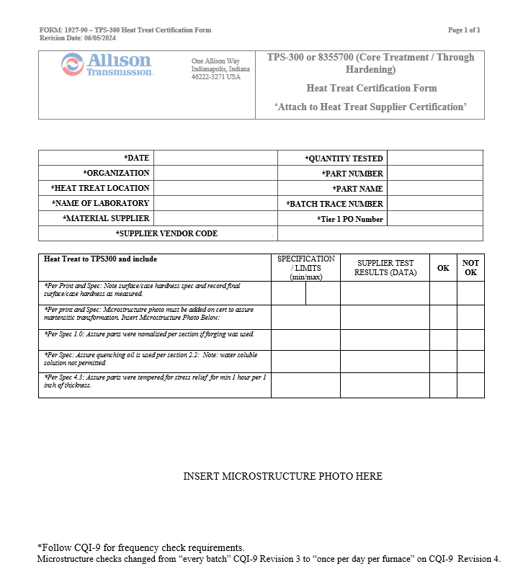
Note case / surface hardness per print specification.
Attach photo of microstructure assuring transformation to Martensite. No dictation allowed.
If forgings, ensure parts were normalized and show evidence per the TPS-247 certification form.
Ensure quenching oil was used. Do not use water soluble.
Ensure parts were stress relieved / tempered after TPS-300 process based on part size per TPS-300 specification.

AT-1927-89 Heat Treat Supplier Management Procedure

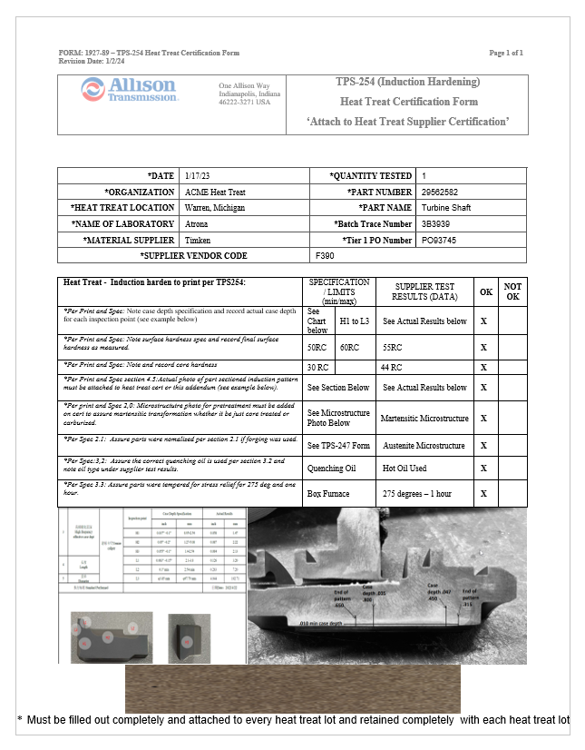
*Follow CQI-9 for frequency check requirements
Microstructure checks changed from “every batch” CQI-9 Revision 3 to “Once per day per furnace” on CQI-9 Revision 4.
requirements

Verify quenching oil was used. Parts can crack if water soluble solution used. Ensure supplier stress relieved parts due to TPS-254 added process stresses.
If a forging was used, then supplier must use TPS-247 form to show compliance.
Paste photo of actual TPS-300 produced microstructure. No dictation allowed. The photo must be of the final martensitic transformation.
Paste photo of actual sectioned part etched to show true induction pattern as noted on print. Do not copy the photo from the print.
Record core hardness.
Record surface / case hardness.
Induction pattern case depth to be charted on a table based on part configuration.

AT-1927-92 Heat Treat Supplier Management Procedure

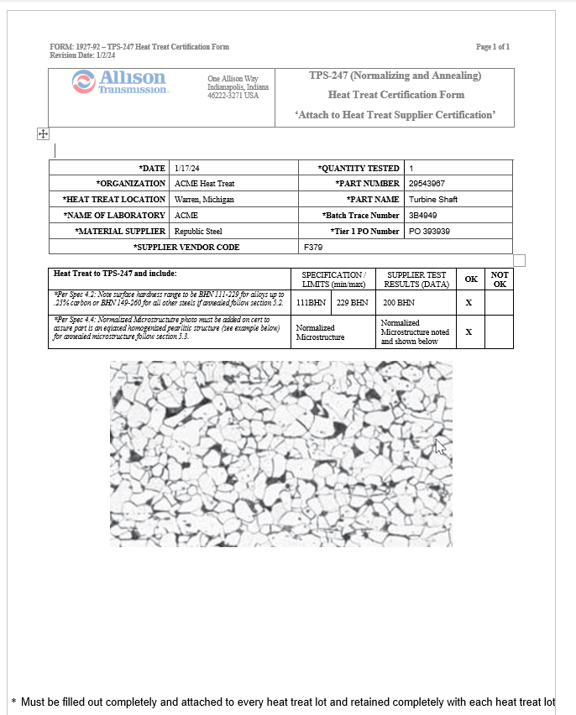
*Follow CQI-9 for frequency check requirements
Microstructure checks changed from “every batch” CQI-9 Revision 3 to “Once per day per furnace” on CQI-9 Revision 4.
requirements

Attach photo of normalized microstructure that meets
TPS-247 requirements.
Note surface hardness requirements based on allowed steel % carbon concentration. BHN 111-229 allows up to .25% carbon. BHN 149-260 allows for all others.

AT-1927-88 Heat Treat Supplier Management Procedure

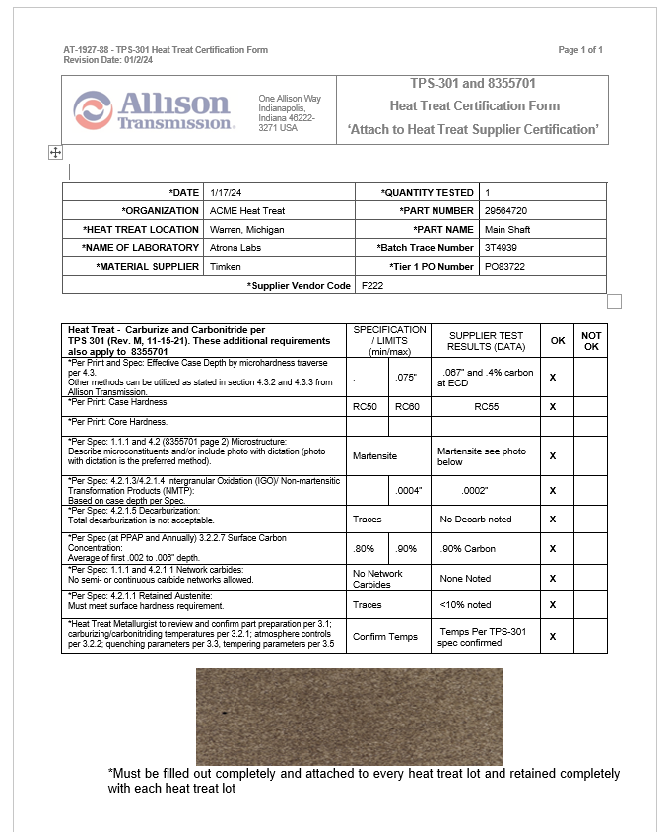
*Follow CQI-9 for frequency check requirements.
Microstructure checks changed from “every batch” CQI-9 Revision 3 to “Once per day per furnace” on CQI-9 Revision 4.
% surface carbon measurements are critical at PPAP and following up with daily potential % carbon checks.
Record IGO based on case depth of print and TPS specification.
Microstructure must be a photo. Dictation is not allowed.
Record Surface / Case Hardness
Record Core Harness (no less than 5 times the case depth from the surface.
Determining Case Depth by:
- Microhardness evaluation to 50 HRC (Hardness Traverse)
- Microstructure evaluation
- .40% carbon – Carbon Gradient Study
Note – All 3 must correlate during PPAP; therefore, carbon gradient study is required for PPAP.
RC31
RC32
RC30
[Grab your reader’s attention with a great quote from the document or use this space to emphasize a key point. To place this text box anywhere on the page, just drag it.]

